Founding 50 Bedrock Campaign Commitment Form
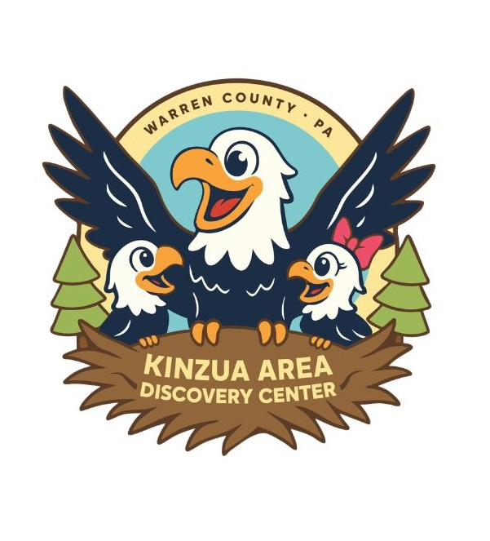
For questions or more information, please contact:
Jennifer Madigan, Executive Director
(814) 723-6350 or jmadigan@kinzuaareadiscoverycenter.org

1. Donor Information
Name _____________________________________________ Company Name ______________________________________
(Print Clearly) (If Applicable)
Address _________________________________________________________________________________________________
Phone (Cell) ________________________________________(Work/Home) ________________________________________
Email Address ___________________________________________________________________________________________

2. Permanent Wall Recognition Wording
Please print exactly how you wish your name or business to appear in perpetuity on the physical Founding Wall:
_______________________________________________________________________________________

3. Investment Level Selection

[ ] | Valley Visionary | $10,000 or greater
[ ] | Eagle-Eye Explorer | $7,500 – $9,999
[ ] | Canopy Creator | $5,000 – $7,499 (Founding 50 Bedrock Minimum)
Total Foundational Pledge Amount: $___________________________

4. Fulfillment Schedule & Method
[ ] | One-Time Investment: Full payment is enclosed or authorized below.
[ ] | Multi-Year Pledge: I/We wish to fulfill this commitment over: [ ] 12 Months [ ] 24 Months
 | Pledge installments will be made: [ ] Monthly [ ] Quarterly [ ] Annually
Preferred Payment Method:
[ ] Check: Enclosed and made payable to Kinzua Area Discovery Center.
[ ] ACH Bank Transfer / Securities: Please send me transfer instructions via email.
[ ] Credit Card: Visa / Mastercard / Amex / Discover
Card Number: ___________________________________ Exp: _________ CVV: _____
5. Authorization & Intent
The Kinzua Area Discovery Center is a disregarded entity of the Jefferson DeFrees Family Center which is a registered 501(c)(3) non-profit organization. Your contribution is tax-deductible to the fullest extent permitted by law. This commitment form represents your intent to fund a permanent cornerstone of our institution.

______________________________________________ ____________________________________________
Donor Signature Date Donor Signature Date

______________________________________________
KADC Representative Signature Date Date

Please return completed form to:
Jennifer Madigan, Kinzua Area Discovery Center, 207 Second Avenue, Warren, PA 16365

To plant a seed and nurture its growth is to believe unconditionally in tomorrow. True giving is providing the deep roots today so that the next generation may reach their canopy of potential tomorrow.
_________________________________

Pledging Over 3 Years

Spreading your gift over 3 years may allow you to increase your capacity to give.

The following chart shows gifts broken down into annual, quarterly, and monthly payments over a three-year term.

GIFT LEVEL | PER ANNUM | PER QUARTER | PER MONTH
$3,000,000 | $1,000,000 | $250,000 | $83,333
$2,000,000 | $666,667 | $166,667 | $55,556
$1,000,000 | $333,333 | $83,333 | $27,778
$750,000 | $250,000 | $62,500 | $20,834
$500,000 | $166,667 | $41,667 | $13,889
$300,000 | $100,000 | $25,000 | $8,333
$200,000 | $66,667 | $16,667 | $5,556
$100,000 | $33,333 | $8,333 | $2,778
$75,000 | $25,000 | $6,250 | $2,084
$50,000 | $16,667 | $4,167 | $1,389
$25,000 | $8,333 | $2,083 | $694
$10,000 | $3,333 | $833 | $278
$5,000 | $1,667 | $417 | $139

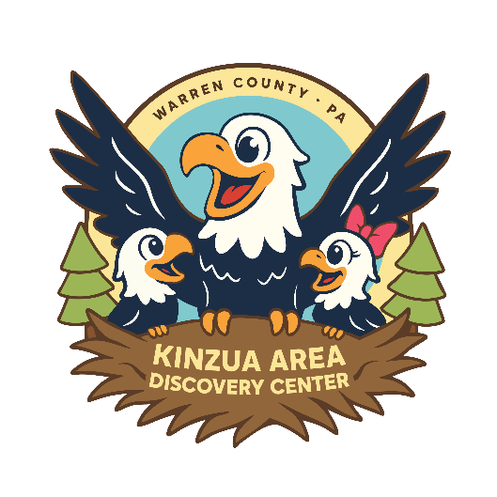
Share. Play. Create. Discover.

